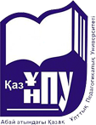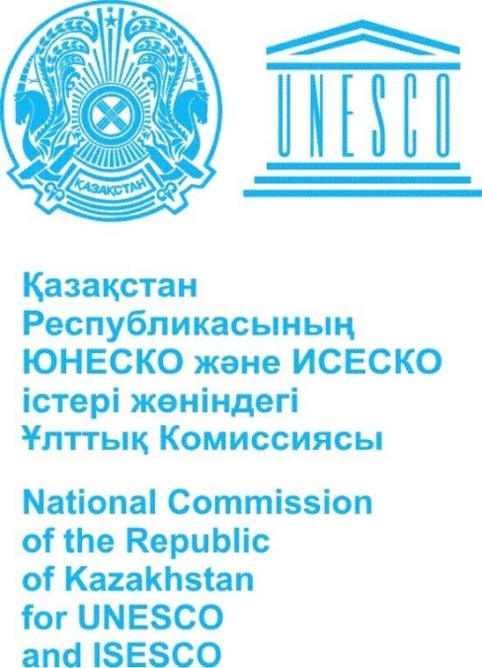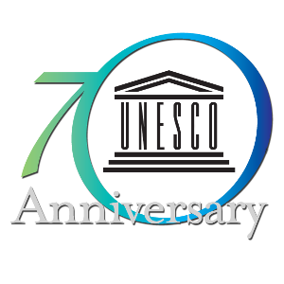

The National Commission of the Republic of Kazakhstan for UNESCO and ISESCO
The Ministry of Education and Science of the Republic of Kazakhstan
Kazakh national pedagogical university named after Abai
UNESCO chair on pedagogics

In September 24-25, 2015
Organizes the International scientific and practical conference –
"Realization UNESCO strategy for preparation of pedagogical staff: Problems and ways of innovative technologies introduction to educational space", devoted to celebration of the 70 anniversary of UNESCO under the auspices of the cultures rapprochement international decade for 2013-2022.
Venue: Republic of Kazakhstan, Almaty, Kazakh national pedagogical university named after Abai, Dostyk Avenue, 13
Key areas for discussion at the conference:
1. Psychology and pedagogical bases of modern information introduction technologies and training techniques of students of higher educational institutions
2. An assessment of professional education development programs results and management of knowledge in modern educational institution
3. Culture, art and education in the sustainable development context of Kazakhstan
4. Modernization of physical culture and sport in modern society
5. Methodological problems of innovative technologies and innovative techniques introduction in educational process of institutions
6. Problems of the state’s educational systems of Eurasian Economic Union participants on integration of education into the international and European educational space.
It is possible to expand the range of issues on the results of applications. Scientists, teachers, research associates, undergraduates, doctoral candidates, and all interested in discussion of these problems are invited to conference.
To attention of conference participants! It is necessary to full-time participation in the conference because of the absence of organizational fee for participation and publication. In the case of material’s inconsistency to declared problematics the organizing committee has the right to refuse in publication. Compliance with the technical requirements for the preparation of scientific articles is mandatory.
Working languages of conference: Kazakh, Russian, English.

REQUIREMENTS TO ARTICLES
Text format: WordforWindows – 95/97/2000. Page format: A4 (210×297 mm). Fields: 2,5 cm – from all directions. Font: the size (size) – 14; type – Times New Roman. A name, a middle name, a surname of the author(s) are printed by lower case letters. A name of article is printed by capital letters, a font is fat, alignment on the center. On the next line – the full name of the organization, the city, after 2 intervals – the text printed through an unary interval, a paragraph space – 1,25 cm, alignment on width. Drawings should be carried out the sizes not less 60×60 mm and no more 110×170 mm in a format * jpg, * bmp. The name and numbers of drawings are specified under drawings, names and numbers of tables – over tables. Tables, schemes, drawings, formulas, graphics shouldn't go beyond the specified fields (a font in tables and in drawings – not less than 11 pt). Footnotes on literature should be in the square brackets. Existence of the list of references is obligatory. Don’t put the transfers. Volume is no more than 5 pages.
In electronic option article has to be in the separate file. In a name of the file specify a surname of the author and the first three words of the theme of article.

EXAMPLE OF THE ARTICLE PREPARATION

Sultanova Madina Ernestovna

SPECIFICS OF SACRAL KNOWLEDGE TRANSFER OF CENTRAL ASIA
NOMADS
(on the example of Kazakh ornament traditions)
Kazakh national pedagogical university named after Abai, Almaty

The articles have to be sent by following address:
The Republic of Kazakhstan, 050010, Almaty, Dostyk Avenue, 13, UNESCO chair on pedagogics of the KAZNPU named after Abai, cab.107А
Phones: 8(727) 2938782. 2910266
We ask to confirm your participation and send reports before June 10, 2015. Please send articles by an e-mail on the address: zanna_73@ mail.ru or unesco@kaznpu.kz
Responsible secretary: candidate of pedagogical sciences, associate professor Shaygozova Zh.N. Ph. 87074146490

